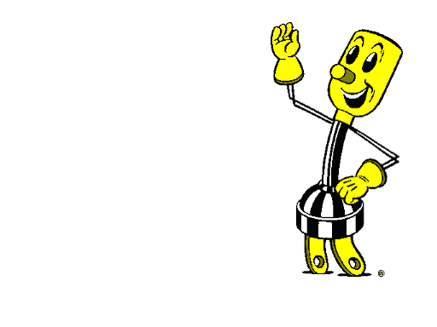
Bayfield Electric Cooperative offers a special low off-peak electric rate for electric heating systems that are wired for peak load control. Under this program, the electric heat is metered separately (dual meters) and is switched off during peak demand periods via a load control receiver installed by Bayfield Electric. The off-peak meter will be billed at the standard rate until all load control wiring is completed.
What is a Dual Fuel Heating System?
A dual fuel heating system is any configuration of electric heat that is installed in combination with an automatic, non-electric backup source of heat, or wood burning stove. When a peak control period occurs, the electric heat is switched off.
What is an Electric Thermal Storage Heating System?
An electric thermal storage system (ETS) is an electric heating system using high density brick within a room heater or central heating system to store heat for use during peak control period. Because an ETS system recharges itself with electric during off peak hours, usually at night for use during the day, no back up heat source is needed. ETS systems are designed to be switched off on a daily basis.
Bayfield Electric Cooperative
68460 District Street
P. O. Box 68
Iron River WI 54847 (715)372-4287 (800)278-0166 Fax (715) 372-4318 www.bayfieldelectric.com
Metering Requirements
Controlled heating systems require two meters, one for the main service and one for the controlled heating loads. In most cases, that means the installation of a dual meter socket and two parallel services. Also if you have different types of electric heat a third meter may be needed. Please wire for the heat meter on the right side. Please contact the cooperative to obtain dual metering specifications. Note: the off peak meter will be billed at the standard rate until all load control wiring is in place. Contact your cooperative to answer any questions about your needs and our requirements.
What is Permitted on the Heat Meter
The electric heating is broken into 2 groups. 1. Electric in floor and ETS (electric thermo storage systems).
2. All other electric space heating equipment, cooling systems and hot water systems.
All electrical heating units must be hard wired, not plug in equipment like dryers, stoves, hot tubs, plug in air conditioners and other non- controlled loads are not allowed on the heat meter.

When Are the Control Period and How Long Are They?
Dual fuel control periods usually occur on the 5 to 15 coldest and 9 to 15 hottest days of the year. Winter control periods usually start about 5 p.m. and end about 11 p.m. If the following mornings are severely cold, load control usually may occur then as well. Summer load control usually starts about 1:00 p.m. and ends about 5:00 p.m. Cooling loads are cycled on and off every 15 minutes during the summer load control.
ETS (Electric thermo storage) heating control periods occur daily. Generally speaking, the winter control periods (November –April) start about 5-6 a.m. and last until late morning or early afternoon. Then , heating to recharge and are switched off again until 10-11 p.m. Summer control periods (May-October) start at 11:35 a.m. and last until 8:25 p.m. ETS load control does not occur on weekends or holidays unless it is a full load control (high peak) day.

Revised: 10/21/2015

When Are Water Heaters Switched Off?
Water heaters wired through the heat meter are wired for daily load control. We encourage the use of this program.
What Are the Control Wiring Requirements?
The installation of a load control receiver to switch off heating and cooling loads is required to receive the off peak rate for electric heat. In most cases, the DUAL METERING WIRING SPECIFICATIONS.
Please provide two (2) # 10 wires for each water heater plus three (3) #12 wires (one white) from the meter socket to the lower portion of the load center. In most cases, low voltage wiring, as shown in the dual metering wiring specifications, is also required, and must be in place before the load control receiver is installed.

