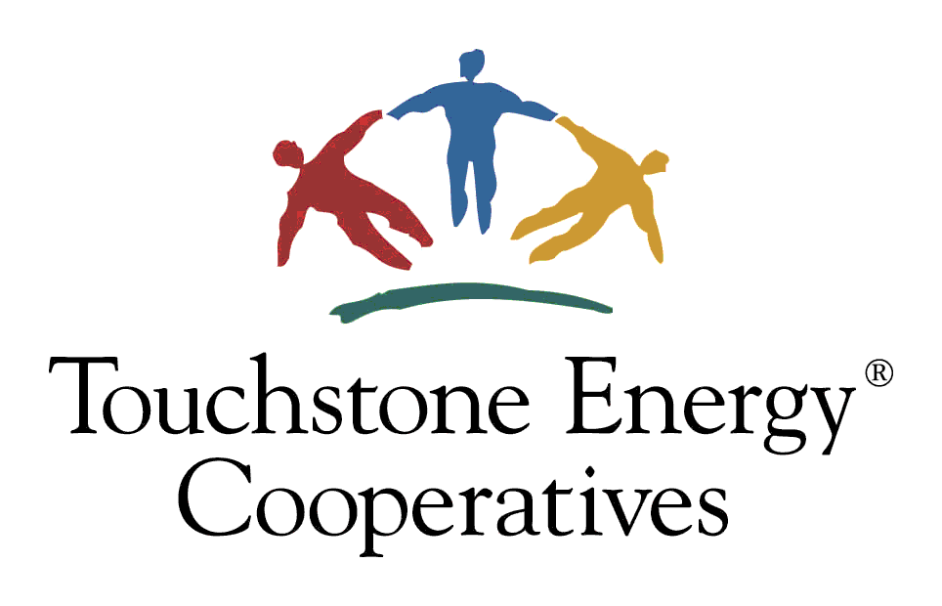 |  |  | Touchstone Energy® Home program  2020 Energy Efficiency Incentive Form  (Dairyland Power Cooperative System Only / Wisconsin New Homes)  This institution is an equal opportunity provider.
ELIGIBILITY CRITERIA
- To qualify for this program’s $500 incentive, ONE of the following four Program/Code requirements must be met:
- Touchstone Energy® Home Program To qualify for the incentive under this Program/Code, the following are required:
- A qualified rater or inspector* must verify ALL the requirements on the attached checklist have been met unless Not Applicable.
- Submit the completed checklist and this incentive form with Section 1 and Section 2 completed.

- Touchstone Energy® Home Program with blower door test in place of Ductwork & Air Infiltration Control requirements To qualify for the incentive under this Program/Code, the following are required:
- A qualified rater or inspector* must verify all requirements on the attached checklist have been met unless Not Applicable, except for the requirements in the Ductwork & Air Infiltration Control category.
- A blower door test is required in place of the Ductwork & Air Infiltration Control requirements. Less than 3 air exchanges/hour at -50 Pascal is considered passing. Person performing the test must complete Section 3 of this incentive form.
- Submit completed checklist and this incentive form with Section 1, Section 2, and Section 3 completed.

- 2012 International Energy Conservation Code To qualify for the incentive under this Program/Code, the following are required:
- A qualified rater or inspector* must provide documentation showing compliance with IECC 2012 using REScheck software.
- A blower door test is required. Less than 3 air exchanges/hour at -50 Pascal is considered passing. Person performing the test must complete Section 3 of this incentive form.
- Submit documentation showing compliance with IECC 2012 and this incentive form with Section 1 and Section 3 completed.

- Focus On Energy® New Homes Program To qualify for the incentive under this Program/Code, the following are required:
- A Wisconsin-built home must meet the energy efficiency requirements of Focus On Energy New Homes Program.
- Submit documentation showing compliance with Focus On Energy New Homes Program & this incentive form with Section 1 completed.
*A qualified rater or inspector refers to a person who is knowledgeable in building standards, has experience in using blower door test equipment, if blower door test is performed, and is approved by your electric cooperative.

- New home or multi-family dwelling must be on cooperative’s lines.
- For multi-family dwellings, each structure may receive only one $500 incentive and the person requesting the incentive must be the owner of the structure and must be a member of the cooperative.
- Incentives are in place through December 31, 2020. Funds are limited so submit required documentation as soon as possible.
- Required documentation must be submitted within 3 months of certification. If submitted after December 31, 2020, new home will be considered for the 2021 incentive if offered.
- Additional eligibility criteria may apply. Program is subject to change or cancellation without notice. Contact cooperative for details.
- Required documentation listed below must be submitted no later than 3 months after certification.
    - This incentive form
    - Documentation as explained above, depending on which Program/Code was followed
Submit required documentation to: Bayfield Electric Cooperative
PO Box 68
Iron River, WI 54847
Section 1: MEMBER INOFRMATION (Please fill out entire section)
Member Name |  |  | Email  Email addresses will be used for cooperative communication only, including eNewsletters filled with energy saving tips. Opting out now or in the future is always available. Opt out Now
Address |  |  | Account | Phone
City | State | Zip | Date | Member Signature
Which Program/Code requirement has been met to qualify you for this incentive (Program/Code requirements are listed above)?
Touchstone Energy® Home Program Touchstone Energy® Home Program with Ductwork & Air Infiltration Control requirements bypassed
2012 International Energy Conservation Code Focus on Energy® New Homes Program (level 2 requirements)
Section 2: RATER / INSPECTOR VERIFICATION (Please fill out entire section if home satisfies requirements of Program/Code 1 or Program/Code 2 as defined under ELIGIBILITY CRITERIA above)
By signing this form, the rater or inspector certifies that the home has met:
- All requirements in the attached checklist, unless Not Applicable, if member is qualifying with option 1 (Touchstone Energy® Home Program) OR
- All requirements in the attached checklist, unless Not Applicable, if member is qualifying with option 2 (Touchstone Energy® Home Program less the Ductwork & Air Infiltration Control requirements). NOTE: Ductwork & Air Infiltration Control requirements can be marked Not Applicable as a blower door test is being done instead.
Rater or Inspector Name |  | Rater or Inspector Signature |  | Date of Final Inspection
Section 3: BLOWER DOOR TEST VERIFICATION (Please fill out entire section if home satisfies requirements of Program/Code 2 or Program/Code 3 as defined under ELIGIBILITY CRITERIA above)
By signing this form, the person performing the blower door test certifies that the home has met the requirement of less than 3 air exchanges per hour at -50 Pascal. |  |  |  | Air Exchanges Per Hour
Name of Person Performing Blower Door Test |  | Signature of Person Performing Blower Door Test |  | Date of Blower Door Test
OFFICE USE ONLY
Approved Not Approved-Reason: |  |  |  | Total Incentive Issued: $
Cooperative Representative: |  |  |  | Date:

